**Setting up your DVWA website**

To run the DVWA website, which lets your students try to hack a live site, you will need a webhost that also supports php and mySQL. If you can set up a Linux box, it’s hours or days easier. Just follow the instructions on the following link to set up your site.

<https://www.thomaslaurenson.com/blog/2018/07/12/installing-and-configuring-damn-vulnerable-web-application/>

If you don’t know or have either, you will need to use a web hosting service.

1. First you need to download all the files and the database for DVWA. Go to: <http://www.dvwa.co.uk/>
2. Scroll down and click “Download”. Save the file for later.
3. Go to <https://freewha.com/> (note they delete accounts without monthly visits, so set up your calendar alarms)
4. Make up your own subdomain and choose from the free options. Click Proceed.  
   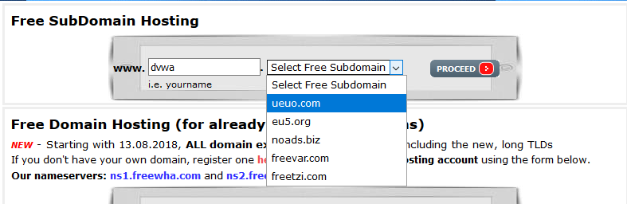
5. On the next page, create your user name and password.
6. You’ll be presented with a page with all your account details. You must save the information because you will need them to do anything with the site. I recommend that you print it out or save it as a PDF and save it to a cloud backup, like your school account’s Google Drive.
7. Click on the link to go to the Control Panel. You will need to log in. (What did I tell you?)
8. On the cPanel page, click on “Activate PHP”. This should turn the button into “Configure PHP”, like below.  
   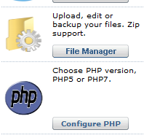
9. Download an FTP client (not server). FTP stands for File Transfer Protocol, useful for transferring files. If you don’t have one, get FileZilla. Again, the client, not the server. Pro tip: For apps I know I may not use again for years, I look for the portable version. This is common with open-source programs, and means you don’t have to install.  
   <https://portableapps.com/apps/internet/filezilla_portable>
10. Enter your login info on the top.  
    
11. You can drag and drop the DVWA-master folder into your remote directory. My initial upload attempt via the web interface failed, so you see the partial DVWA-master folder on the right.  
    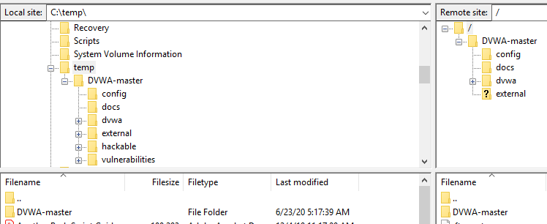
12. When it’s done, after an hour or more, there will be many failed uploads. Highlight them all and then right-click on them. Choose “Reset and requeue all”. You may have to do this a few times, until everything is uploaded.  
      
    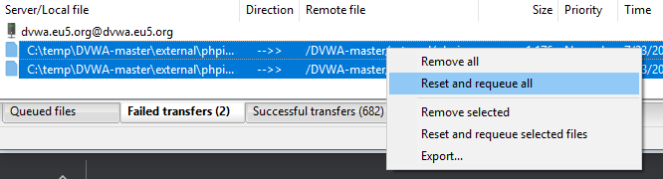
13. Look back at the screenshot for step 11. Notice there’s a question mark on the “external” folder on the right. That means that folder is not completely uploaded. On the left pane, find the “external” folder, and copy all its contents into the webserver’s external folder. Overwrite any files that have a different size.
14. When you’re done, [http://<your domain>/DVWA-master/index.php](http://dvwa.eu5.org/DVWA-master/index.php) won’t work. You’ll need to rename config/config.inc.php.dist as config/config.inc.php
15. You’ll also need to use the cPanel to create a MariaDB. This is compatible with mySQL db, but I stopped at this point. <http://dvwa.eu5.org/DVWA-master> works for me. I’m pretty sure I can make it work but I don’t have the time to figure it out. Hopefully you can continue this work and make it happen!

Again, you can skip all of this if you just set up Linux. But how?

# How to Set Up a Linux Box

Here are some options. I’d be really careful with the last option. Never run the server in the OS you use for personal or work purposes, in case this hackable website leads to real private data.

* Set up an AWS Educator account and apply for credits for yourself and all your students. You’re basically renting computers. Amazon provides $50 of credits but my co-teacher and I used less than $5 of that for 4 sections of students over 1-2 months. One downside is the lack of GUI. Another downside for newbies is AWS uses Bitnami right now instead of Ubuntu, and files and directories are not often where you’d expect.
* Install a virtual machine on your computer. A VM is basically like computer Inception. You have a computer running on a computer (on a computer…) You can wipe it anytime or reload a backup copy, and it will never mess up your host, whether that’s Windows, Mac, or another Linux. The most popular free solution right now is [Oracle’s VirtualBox](https://www.virtualbox.org/). The easiest Linux distro to use is probably [Ubuntu](https://ubuntu.com/download/desktop). If you’re running on older (slower) hardware, use [Linux Lite](https://www.linuxliteos.com/download.php), which is based on Ubuntu.
* If you have a slow computer you don’t use anymore, even a netbook, wipe it and install Linux on it. I have a Pentium core laptop that takes 10 minutes just to boot into Windows, that feels like a brand new computer in Linux. You can refer to [guides like this](https://www.techsolveprac.com/install-linux-lite-usb-windows/) to set up a flash drive or CD
* If you’re on Windows 10, you can also use [WSL](https://ubuntu.com/wsl) or [WSL2](https://www.omgubuntu.co.uk/how-to-install-wsl2-on-windows-10), which allows you to run Linux side by side with Windows. You can even get a full-fledged GUI environment.  
    
  Here are step-by-step directions:
  1. <https://pureinfotech.com/install-windows-subsystem-linux-2-windows-10/>
  2. <https://autoize.com/xfce4-desktop-environment-and-x-server-for-ubuntu-on-wsl-2/>
  3. Instead of b, you can also try <https://www.tenforums.com/tutorials/144208-windows-subsystem-linux-add-desktop-experience-ubuntu.html> with <https://www.tenforums.com/tutorials/144208-windows-subsystem-linux-add-desktop-experience-ubuntu-6.html#post1961524>

This is what Linux on Windows looks like:  
